First Create Instance in AWS
Login to account
Launch the Instance
Goto SSH tab
Copy the key
Past in terminal for remote connection
Once we start the and install Servers (yum install nginx),(yum install httpd) in remote server on which you want to work .then past the Ipv4 in the browser.
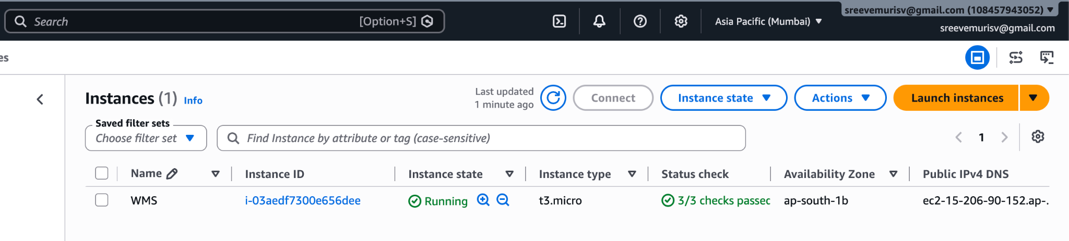
1) Apache HTTPD
sudo yum install httpd -y
sudo systemctl start httpd
sudo systemctl status httpd
sudo systemctl enable httpd
2) TO COPY THE CODE httpd
/var/www/html/
→ to assign port number {80}
- - /etc/httpd/conf/httpd.conf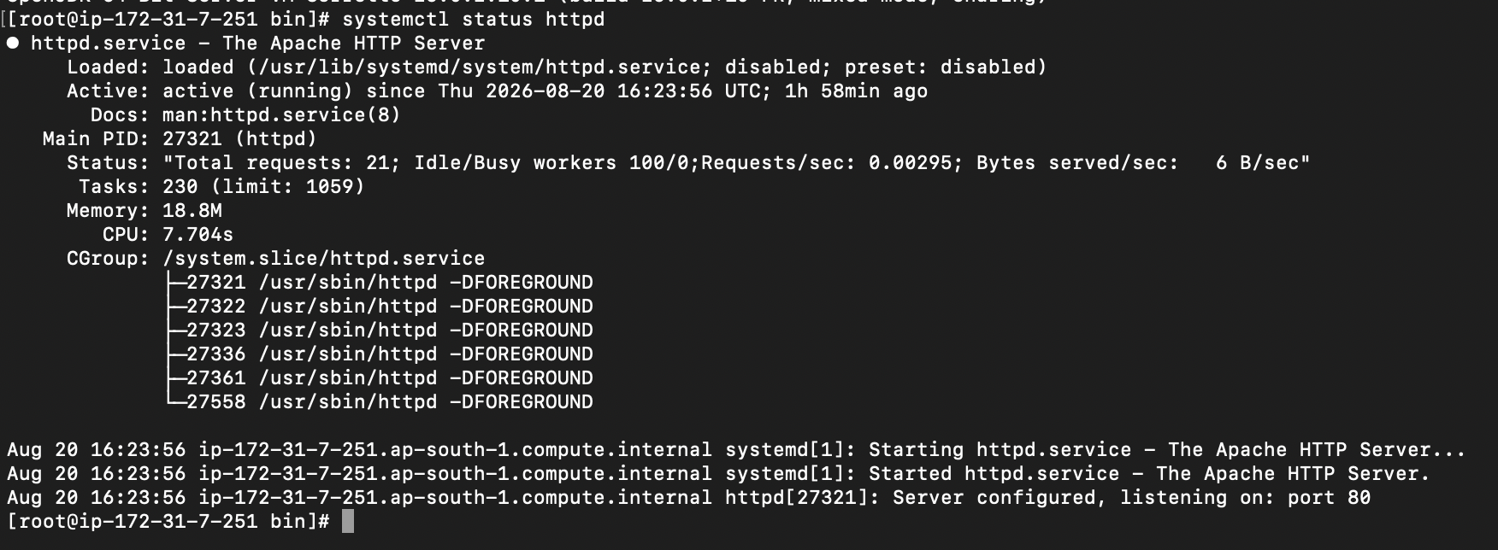

3) Nginx
sudo yum -y install nginx
sudo systemctl start nginx
sudo systemctl status nginx
sudo systemctl enable nginx
4) TO COPY THE CODE TO nginx
/usr/share/nginx/html/
→ to assign port number {82}
- - /etc/nginx/nginx.conf
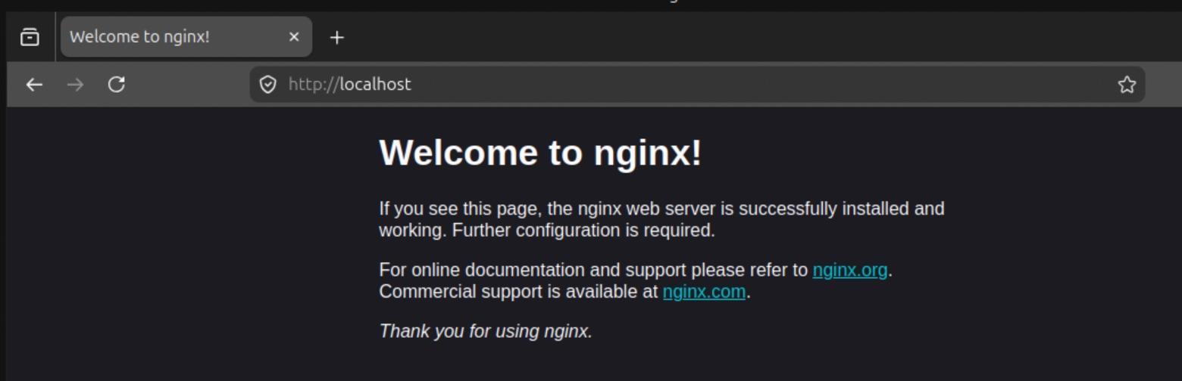

5) Apache Tomcat
I’m downloading apache
→ cd /opt/ wget https://dlcdn.apache.org/tomcat/tomcat-9/v9.0.121/bin/apache-tomcat-
9.0.121.tar.gz
→ tar -xvf apache-tomcat-9.0.121.tar.gz
➔ Cd bin/
→ ./startup.sh
→ publicip:8080
- - To assign port number {8080}
/apache-tomcat-9.0.80/conf/server.xml
